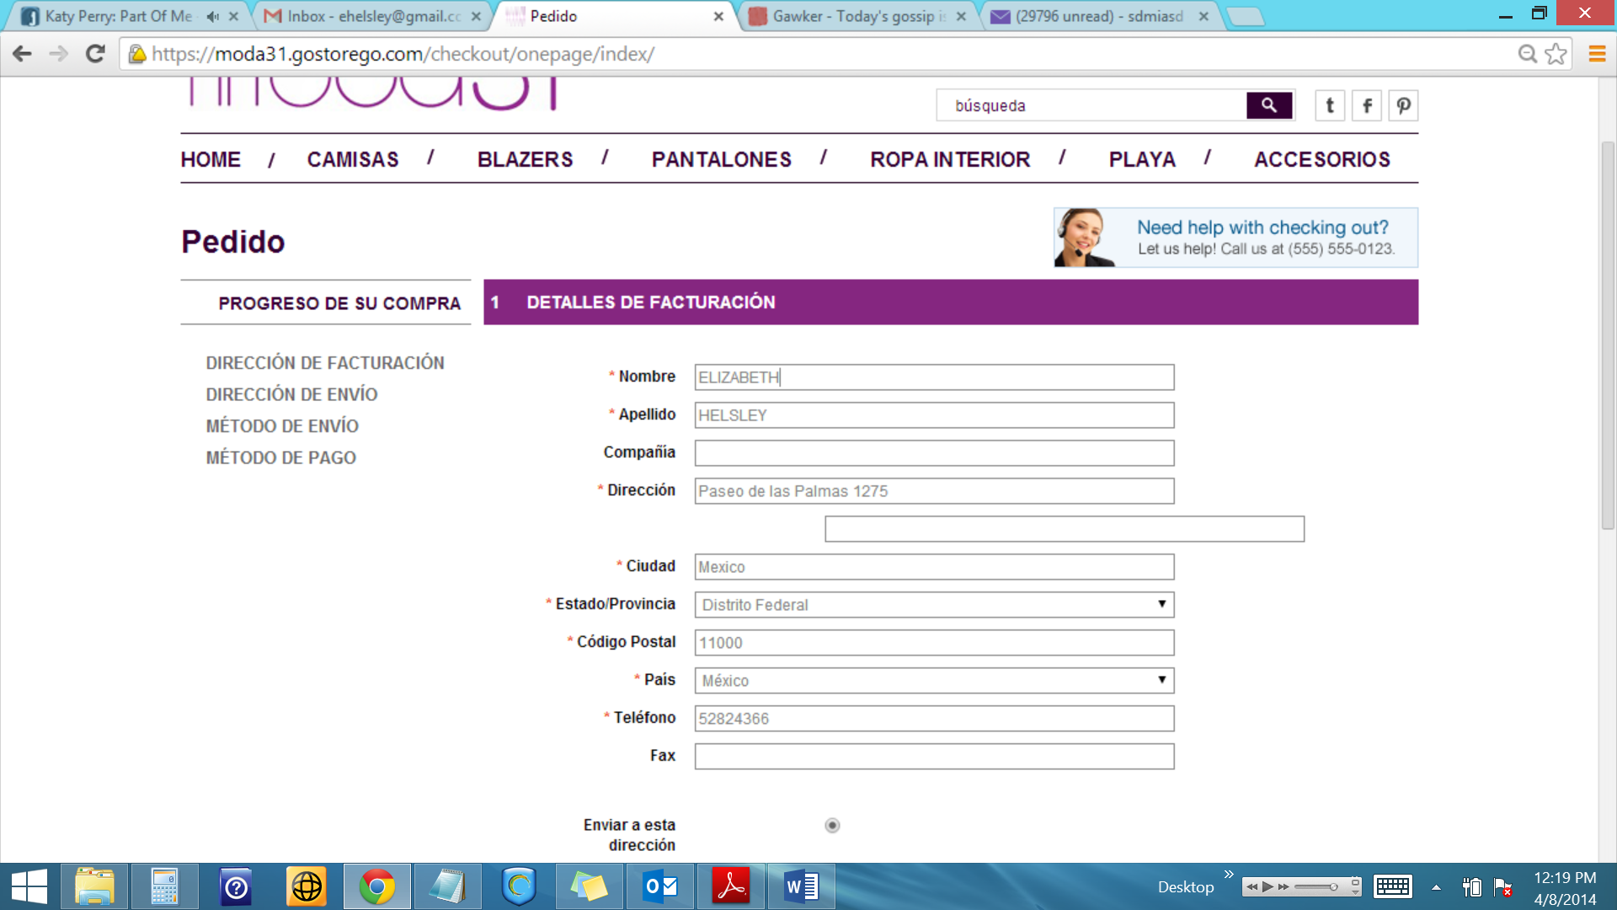

1. The box with the woman on the top right…can we change that to say:

“¿Necesita ayuda con su compra? Hablenos al 01-800-681-6521!”

1. Is there a way to configure this so that it is only available for Mexico customers? We don’t want a drop down with all of the countries because we are only shipping to Mexico.
2. There is a blank field below the address. We need this to say “Colonia”.
3. In the Metodo de Envio (Shipping Method) section, it should be free shipping so no charge.
4. In the Metodo de Pago (Payment Method) section, we are going to have three payment methods:
   1. PagoFacil

Here are the APIs

|  |  |
| --- | --- |
| **Entorno de Producción** | |
| API Sucursal | f0620c66b100e63cb24c91d2d8428e89b9e27c26 |
| API Usuario | 1cfc064c08c38ee287bde7263465c746aa169e40 |

* 1. Credit Cards
  2. PayPal